IBM ASSIGNMENT–2

**Name: Gugan Ananth A**

**College: St. Joseph’s Institute of Technology**

ASSIGNMENTQUESTION:

**Buildapythoncode,assume you get temperature and humidity values (generated with randomfunction to a variable) and write a condition to continuously detectalar min case of high temperature.**

PYTHONCODE:

import randomimport timewhile(1!=0):

temperature = random.random()humidity =random.random()

#round(temperature,2)#round(humidity,2)("print Temperature: ","%.5f" % temperature)print("Humidity: ","%.5f"%humidity)time.sleep(2)

if(temperature>0.7):print("hightemperature")

if(humidity >0.7):print("highhumidity")

print("")

EXECUTIONRESULT

Program

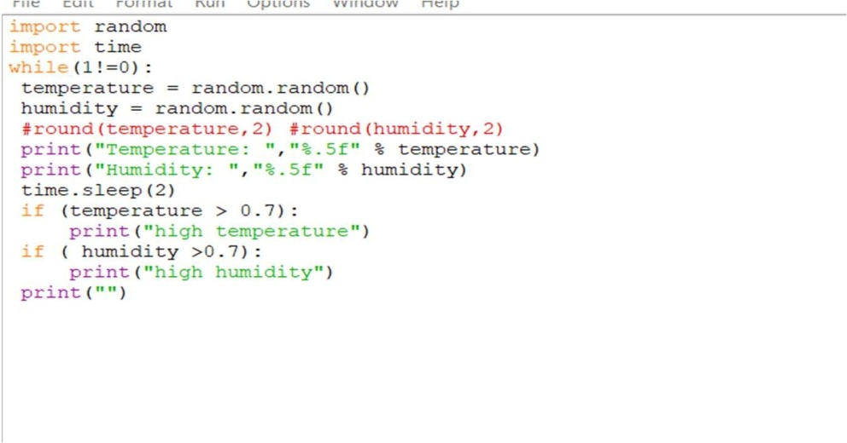

Output

